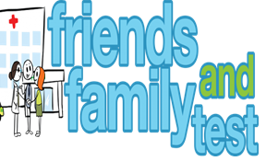
HAVE YOUR SAY TO IMPROVE YOUR CARE!
COMPLETE OUR SHORT QUESTIONNAIRE ON HOW LIKELY YOU ARE TO RECOMMEND OUR SURGERY TO FAMILY AND FRIENDS.
We have been collecting your replies and below are our results for
August 23
Very Good | Good | Neither Good/nor poor | Poor | Very Poor | Don’t Know
42 | 3 | 2 | 0 | 0 | 0

Recent comments:
- This surgery always offers a great service.
- Never feel a burden, always helpful
- Knowledgeable, friendly and helpful.
- The best surgery ever!
- Really go above and beyond.

